**TEMPERATURE BASED FAN SPEED CONTROL**

**INTRODUCTION:**

As technology is developing day by day, we prefer things to be done automatically. The main idea of this project is to replace the manual setting of fan speed by automatically controlling the speed of fan depending on the temperature of the surrounding.

**FAN SPEED CONTROLLER BASED ON TEMPERATURE:**

A fan is something which is we use in many things including an electrical equipment, in engines or other machines to cool down the equipment directly by forcing hot air into the cooler environment outside the machine. A fan is used in laptops and PCs in CPU, Graphics card, etc. as the power dissipation and heat produced may affect the equipment. Generally, fans used in laptops comes with only 2 or 3 possible speed which may result in more power consumption and wastage. This project represents the design of a fan speed control system based on the room temperature using PWM technique.

This project uses a temperature sensor to detect the temperature of the surrounding. The detected data is sent to a microcontroller where the data is processed and the temperature is calculated. According to the temperature, the microcontroller sends the information to the fan to rotate. If the temperature is higher, the fan rotates faster and slower when the surrounding temperature is low.

**WORKING:**

This project uses LM35 temperature sensor to detect the temperature of the surrounding and converts it to electrical (analog) signal which is then sent to the microcontroller, in this project we use Arduino NANO as the microcontroller. The Arduino NANO calculates the temperature and determines the rotating speed of the fan and sends the signal to the fan to rotate at a speed according to the room temperature. A low-frequency pulse-width modulation (PWM) signal, whose duty cycle is varied to adjust the fan’s speed is used. When the temperature is low, the microcontroller sends lesser electrical signal to the fan and the rotating speed becomes low. And when the temperature becomes higher, the electric signal given to the fan also increased which makes the fan rotate faster.

**CIRCUIT DIAGRAM:**

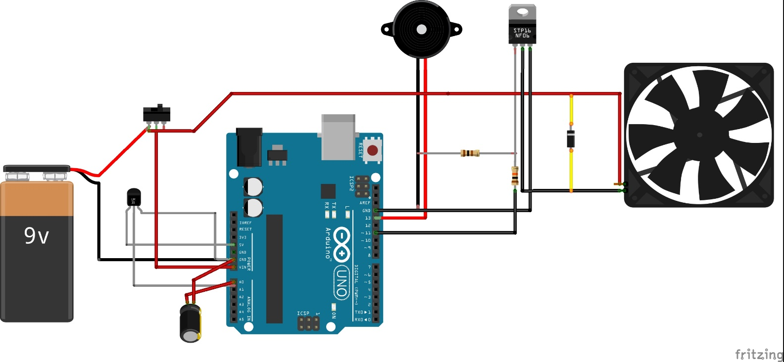

**PROJECT IMAGES:**

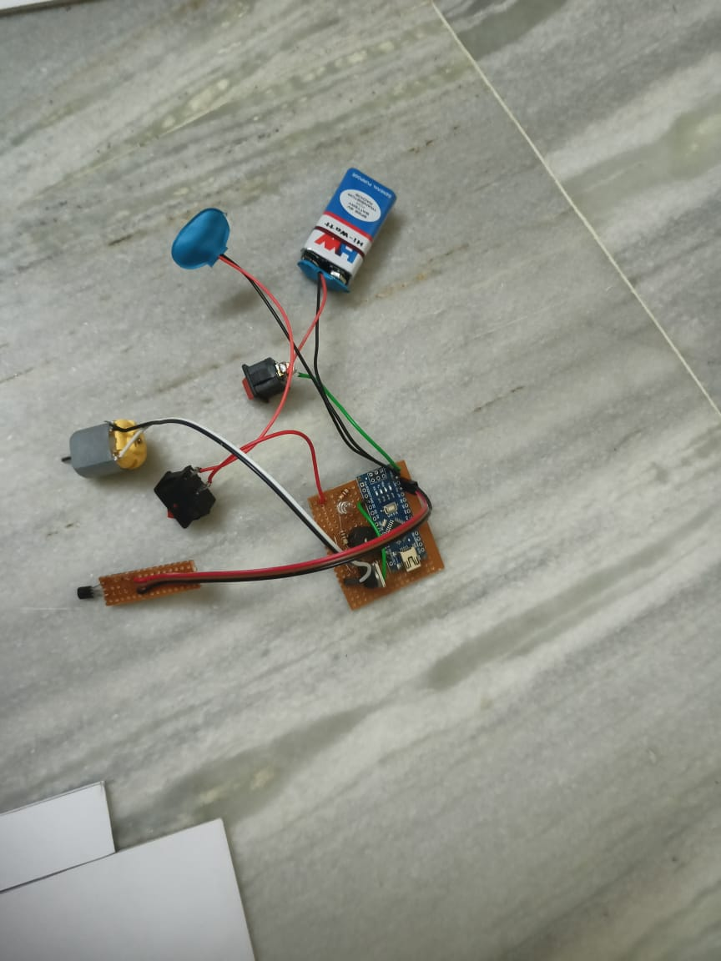

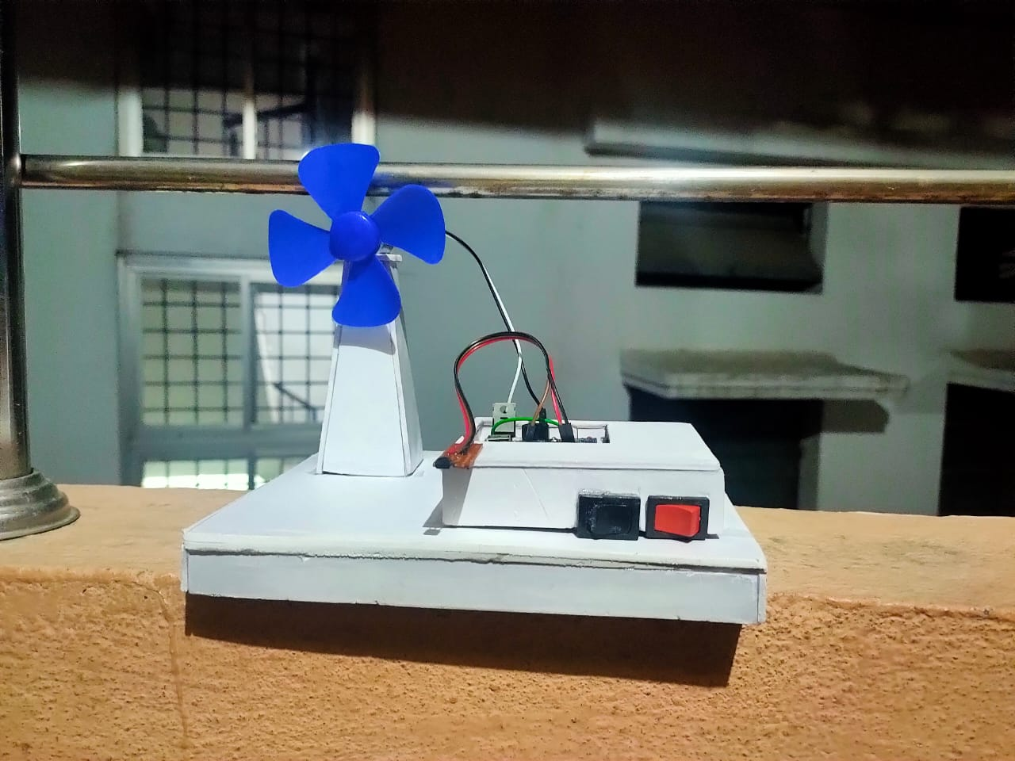

**RESULT:**

Temperature based fan speed controller is useful for cooling the processor in the laptops and personal computers more efficiently as it has different values of speed according to temperature change. It can be implemented for several applications including air-conditioners, water-heaters, snow-melters, ovens, heat-exchangers, mixers, furnaces, incubators and other small-scale industries for cooling the equipment and to save energy/electricity.